**S3 Bucket with Webpage Zip File:**

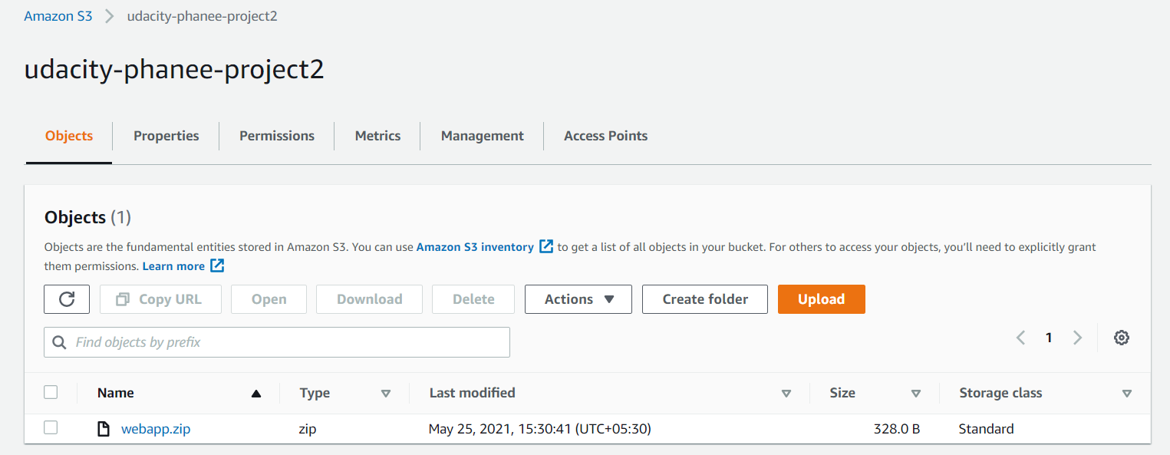

**Role for EC2 to read S3 File:**

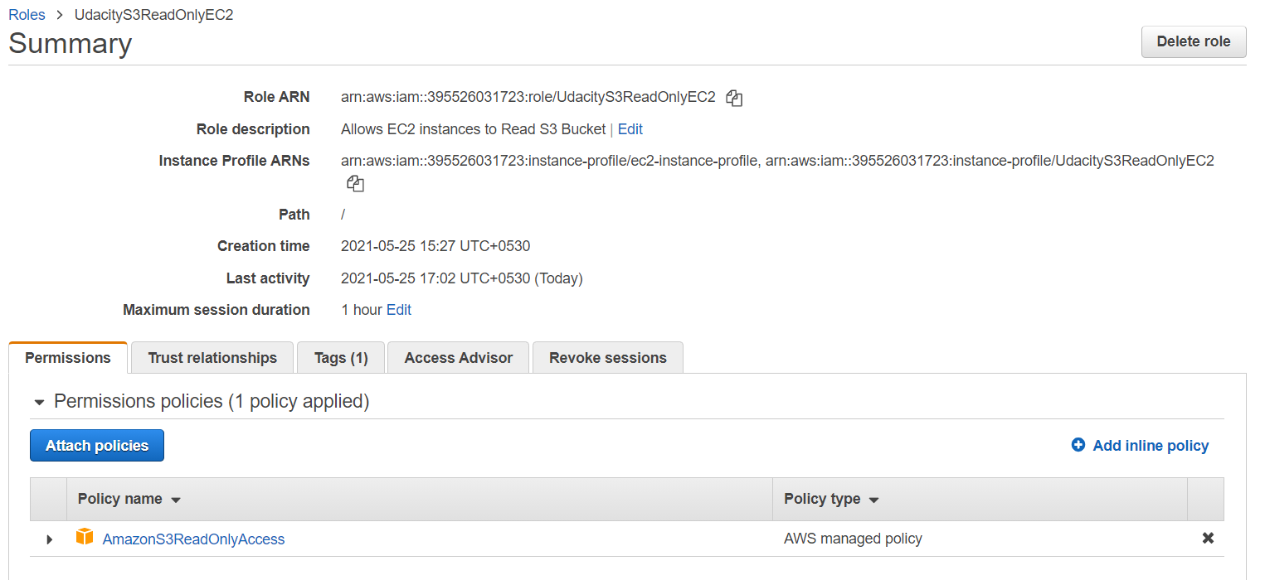

**Instances Running:**

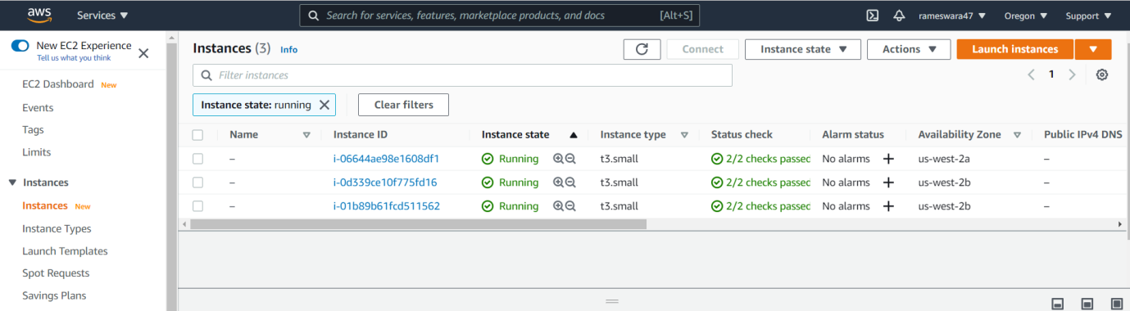

**Auto Scaling Group:**

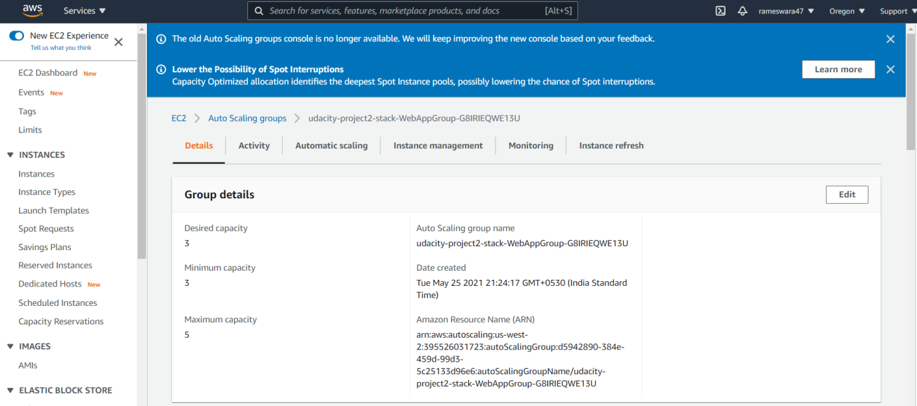

**Launch Configuration:**

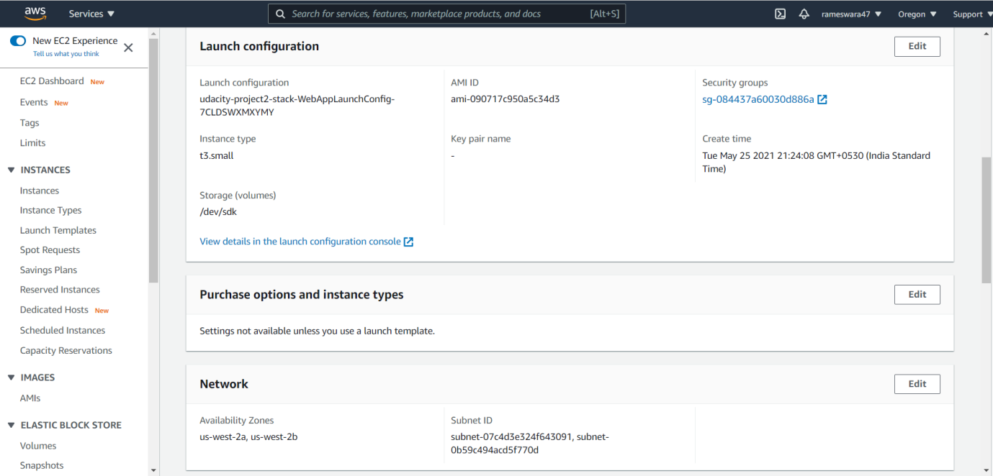

**Load Balancer:**

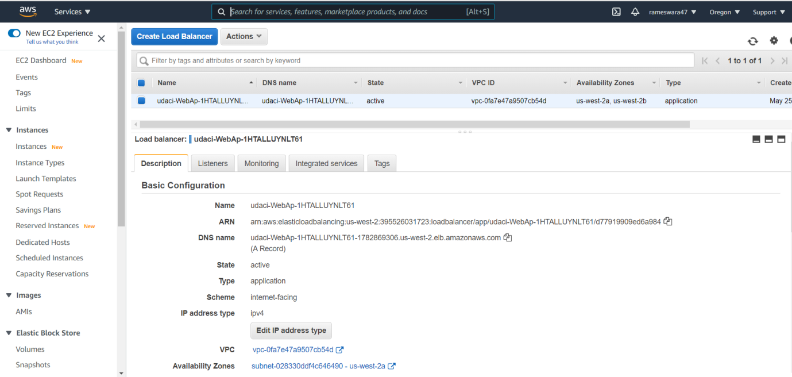

**Cloud formation Stack:**

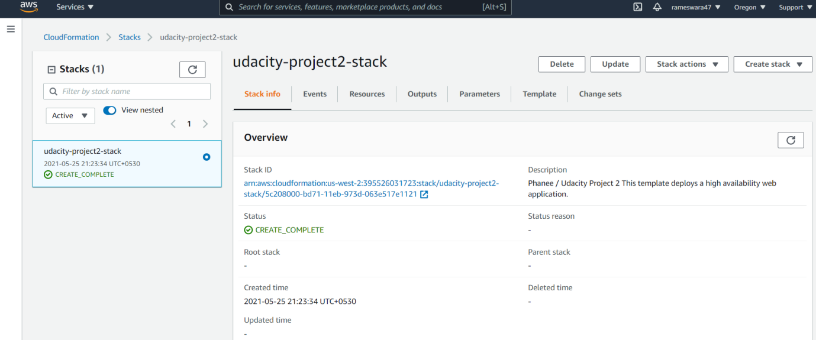

**Cloud formation Output:**

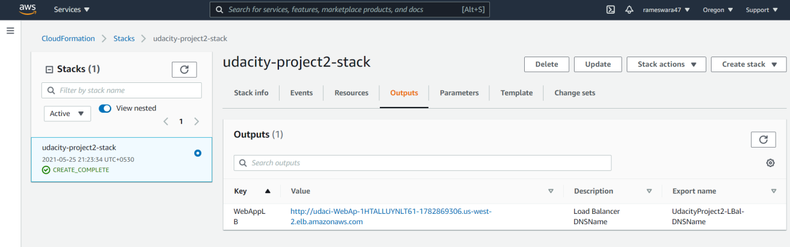

**Webpage:**

